**PJ 1 Report Your Name: Francisco Valadez**

**A. The following is my Java program:**

**// Please copy your Java program into here from your Eclipse window. The code must be colored.**

**// You must not copy Java program from your .java file since the code over there is not colored at all.**

**// You must not show screen prints here.**

//Author: Francisco Valadez  
//Date: 4/22/2021  
//Purpose: This program checks a users password to see if it is secure!  
  
import java.util.Scanner;  
public class Password_Game   
{   
 static String pw; // global variable to hold password for security checking  
 static boolean r1,r2,r3,r4,r5,r6,r7; //7 rulesâ€™ satisfaction indicators: true | false   
   
 public static void main(String[] args)   
 { // begin of main( ) ----------------------------------------  
 int counter = 0;  
   
 System.out.println("Welcome to play the Password game designed by Francisco Valadez!");  
   
 do  
 {  
 ++counter;  
 System.out.println(counter + "====================================================");   
 Scanner scan = new Scanner(System.in);  
 System.out.print("Please enter a password >");  
 pw = scan.nextLine(); // scan to get the password in pw  
   
 if(pw.equals("quit"))  
 {  
 break;  
 }  
   
 System.out.println("You just entered password \"" + pw + "\"");  
 s1(); s2(); s3(); s4();  
 s5(); s6(); s7(); // call 7 methods to check all 7 rules for satisfaction   
  
 if (r1 && r2 && r3 && r4 && r5 && r6 && r7) // all 7 rules are satisfied  
 {  
 System.out.println("Congratulations! Your passowrd \"" + pw +"\" is very secure!");  
 }  
 else // insecure password because at least one rule got violated  
 {  
 System.out.println("The password \"" + pw + "\" violates the following rule(s):");  
 if (!r1)  
 System.out.println("Rule 1: Length invalid - The length of the password must be 8 to 12 only.");  
 if (!r2)  
 System.out.println("Rule 2: No Space - The password must not contain any space or blank character.");  
 if (!r3)  
 System.out.println("Rule 3: At least 2 digits - The password must contain at least 2 digits.");  
 if (!r4)  
 System.out.println("Rule 4: At least 1 upper-case letter - The password must contain at least one upper-case letter.");  
 if (!r5)  
 System.out.println("Rule 5: At least 1 lower-case letter - The password must contain at least one lower-case letter.");  
 if (!r6)  
 System.out.println("Rule 6: At least 1 special character - The password must contain at least one \nspecial character, which can be one of the following 7 choices: '$', '#', '@', '&', '*', '?', '!'");  
 if (!r7)   
 System.out.println("Rule 7: No special numbers - The password must not contain any of the following 4 numbers: 2021, 2020, \n2019, or 2018.");  
 } // print all the violated rules  
 }while(pw != "quit");  
   
 System.out.println("Thank you for playing the Password game designed by Francisco Valadez!");  
 System.out.println(++counter + "==========================================================================");  
   
 } // end of main( ) -------------------------------------------  
   
 // The following are 7 static methods to check those 7 rules:   
 static void s1() // checks if the password is between 7 to 12 characters  
 {   
 r1=false; /* if (check r1 ok) r1=true; */   
 if ((pw.length() > 7) && (pw.length() < 13))  
 {  
 r1 = true;  
 }  
  
 //System.out.println("length: "+r1 + " length: " + pw.length());  
  
 }  
 static void s2() // Checks if the password has any spaces or blank characters  
 {   
 char c;  
 int countspace = 0;  
   
 r2=true; /* if (check r2 ok) r2=true; */   
   
 for(int i = 0; i < pw.length(); i++)  
 {  
 c = pw.charAt(i);  
 if (Character.isWhitespace(c)) // c is a digit   
 {   
 ++countspace; // increment countDigits by 1  
 }  
 }  
   
 if ("".equals(pw) || countspace > 0)  
 r2 = false;  
  
 //System.out.println("spaces: " +r2 + "\t total: " + countspace);  
   
 }  
 static void s3() // Checks if the password has at least 2 digits  
 {   
 r3=false; /* if (check r3 ok) r3=true; */  
   
 int countnum = 0;  
 int[] numbers = {'1','2','3','4','5','6','7','8','9','0'};  
   
 for(int i = 0; i < pw.length(); i++)  
 for(int x = 0; x < numbers.length; x++)  
 if (numbers[x] == pw.charAt(i))  
 {  
 ++countnum;  
 }  
  
 if (countnum > 1)  
 r3 = true;  
   
 //System.out.println("digits: "+r3 + " countnum: " + countnum);  
  
 }  
 static void s4() // Checks if the password has at least 1 upper-case character  
 {   
 r4=false; /* if (check r4 ok) r4=true; */  
   
 int countUpper = 0;  
 char[] letters = {'A','B','C','D','E','F','G','H','I','J','H','I',  
 'J','K','L','M','N','N','O','P','Q','R','S','T','U','V','X','Y','Z'};  
   
 for(int i = 0; i < pw.length(); i++)  
 for(int x = 0; x < letters.length; x++)  
 if (letters[x] == pw.charAt(i))  
 countUpper++;  
 if (countUpper > 0)  
 r4 = true;  
   
 //System.out.println("upper: "+r4 + " countUpper: " + countUpper);   
 }  
 static void s5() // Checks if the password has at least 1 lower-case letter  
 {   
 r5=false; /* if (check r5 ok) r5=true; */  
   
 int countLower = 0;  
 char[] letters = {'a','b','c','d','e','f','g','h','i',  
 'j','k','l','m','n','o','p','q','r','s','t','u','v','x','y','z'};  
   
 for(int i = 0; i < pw.length(); i++)  
 for(int x = 0; x < letters.length; x++)  
 if (letters[x] == pw.charAt(i))  
 countLower++;  
 if (countLower > 0)  
 r5 = true;  
   
 //System.out.println("lower: "+r5 + " countLower: " + countLower);   
 }  
 static void s6() // Checks if the password has at least 1 special character  
 {   
 r6=false; /* if (check r6 ok) r6=true; */  
   
 int specialAmount = 0;  
 char[] special = {'$','#','@','&','*','?','!'};  
   
 for(int i = 0; i < pw.length(); i++)  
 for(int x = 0; x < special.length; x++)  
 if (special[x] == pw.charAt(i))  
 specialAmount++;  
 if (specialAmount > 0)  
 r6 = true;  
   
 // System.out.println("special: "+r6 + " specialAmount: " + specialAmount);   
 }  
 static void s7() // Checks to make sure that the pasword does not contain '2021', '2020', '2019', '2018'  
 {   
 r7=true; /* if (check r7 ok) r7=true; */  
   
 //string[] year = {"2021", "2020","2019","2018"};  
   
 if (pw.contains("2018") || pw.contains("2019") || pw.contains("2020") || pw.contains("2021"))  
 r7 = false;  
   
 //System.out.println("year: "+r7);  
 }  
  
} // end of class Password

**B. The following is the complete output of my 3 test cases: [You must show 3 test cases.]**

**// Please copy your Eclipse console output into here.**

**Test Case 1:**

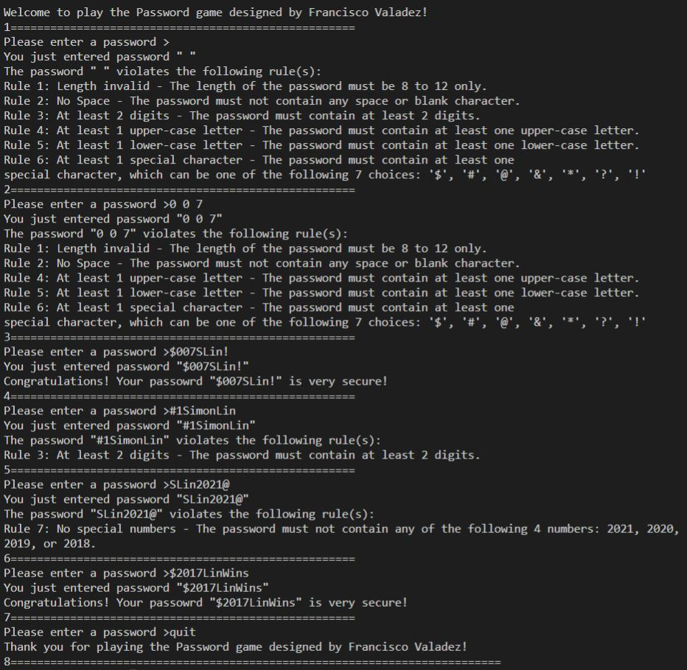

**Test Case 2:**

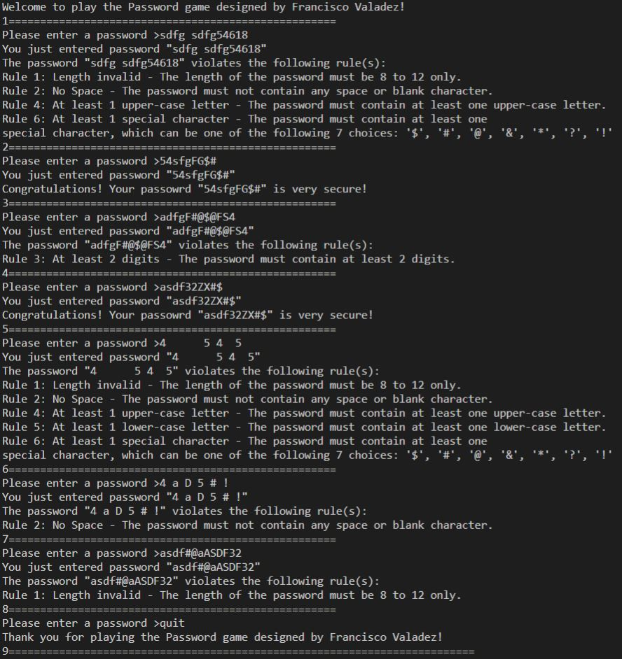

**Test Case 3:**

